Invention Disclosure: Apparatus

# Title of the Invention: Peripheral Intra-Operation Voltage Scaling

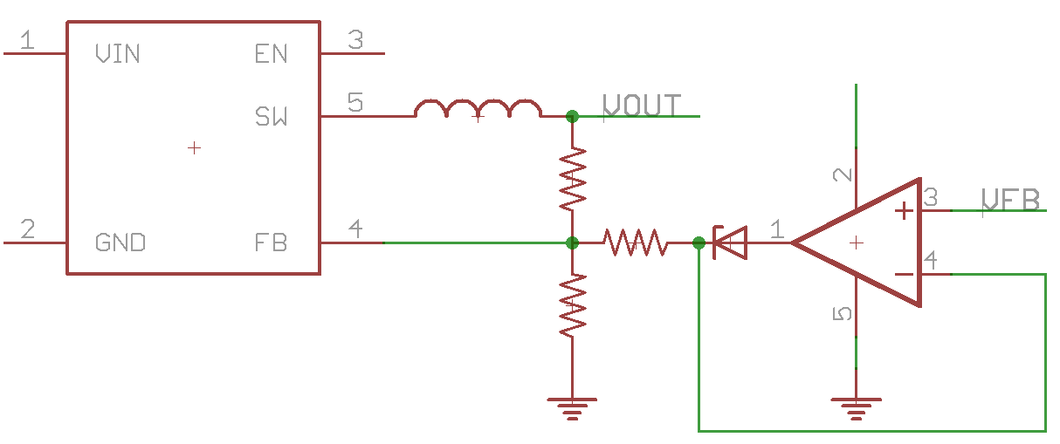

Figure

A typical Switched-Mode Power Supply (SMPS) is shown in Figure 1. The SMPS converts the input voltage (VIN) to a defined output voltage (VOUT). VOUT is controlled by the resistor chain between the switch (SW) and feedback (FB) pins.

IODVS adds additional circuitry in order to modulate VOUT. The resistor/diode/opamp configuration is used to modulate the current input to the FB pin, which in turn modulates VOUT. The speed at which this transition occurs allows for a peripheral driver to change the supply voltage to the peripheral during